Name:konyala sai vardhan reddy

Student id: **700745733**.

Github link: https://github.com/vardhan141/ml-assignment-1

Recorded video link: <https://drive.google.com/file/d/13U86wfJd9xr9CMkzWe7vJLKJqY-SqPk0/view?usp=sharing>

Question 1:

Source Code and output:

Question 2:

Source Code and output:

Question 3:

Source Code and output:

Question 4:

Question 5

Source Code and output:

Question 6

Source Code and Output:

Question 7

Source Code and Output:

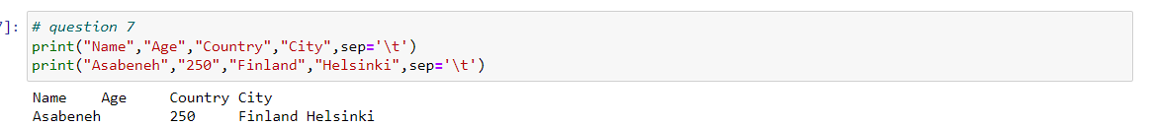

Question 8

Source Code and Output:

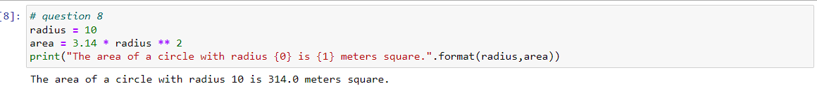

Question 9

Source Code and Output:

Question 10:

First given the diagram we can create a dataset with 8 points with 2 classes since one class is marked with X and other with we can use 1 and 0 to represent them respectively.

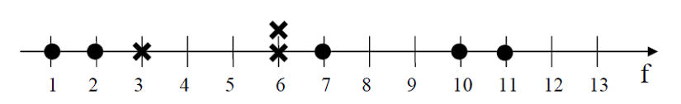

|  |  |
| --- | --- |
| Input | Output |
| 1 | 0 |
| 2 | 0 |
| 3 | 1 |
| 6 | 1 |
| 6 | 1 |
| 7 | 0 |
| 10 | 0 |
| 11 | 0 |

Now we have to 50 50 split the data

Since we have 8 points split into 4 train and 4 test points

The first part is training set

|  |  |
| --- | --- |
| Input | Output |
| 1 | 0 |
| 2 | 0 |
| 3 | 1 |
| 6 | 1 |

The second part is test set

|  |
| --- |
| input |
| 6 |
| 7 |
| 10 |
| 11 |

When k=3 we will take three nearest neighbors it’s a one-dimensional data so let’s calculate the distance

Distance formula=MOD(X1-X2) where X1=Training data point X2=Test data point

For test input 6

MOD(1-6)=5

MOD(2-6)=4

MOD(3-6)=3

MOD(6-6)=0

Since we take 3 closest distance they are 2,3,6 the majority class has output as 1 or X so label for 3 =X

In the same way for 7,10,11 its going to be 1 or X

|  |  |
| --- | --- |
| Input | output |
| 6 | 1 |
| 7 | 1 |
| 10 | 1 |
| 11 | 1 |

Confusion matrix for above data is given by

|  |  |
| --- | --- |
| output | Predicted output |
| 1 | 1 |
| 0 | 1 |
| 0 | 1 |
| 0 | 1 |

Here we take X as 1 or positive and as 0 or negative

True negative= 0, False positive=3,False negative=0,True positive=1

|  |  |
| --- | --- |
| 0 | 3 |
| 0 | 1 |

X

Accuracy=(TP+TN)/(P+N)

=(1+0)/(1+3)=1/4=0.25

Sensitivity=(TP)/(TP+FN)

=1/1=1

Specificity=TN/(FP+TN)

=0/(3+0)=0